Bluetooth controlled Servo motor

Introduction

The android app sends data packets to the Bluetooth module. The Bluetooth modules sends this data packet to Arduino Uno through Serial Communication. Arduino Uno is programmed to generate control signal for the servo motor depending upon the value of the data packet.

Components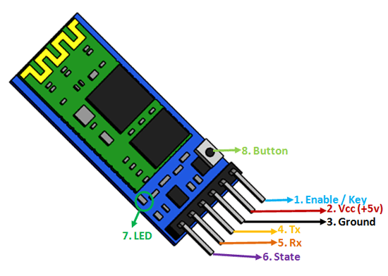

Arduino uno

SG90 servo motor

HC-05blurtooth module

Breadboard

Connecting wires

Application
1.Wireless communication between two microcontrollers
2. Communicate with Laptop, Desktops and mobile phones
3. Data Logging application
4. Consumer applications
5. Wireless Robots
6. Home Automation

Objective
During this activity ,you will help students to achieve following objectives
1. Understanding the principle and operation of bluetooth system
2. Design algorithm and flowchart for controlling servo motor using GSM
3. Programming Bluetooth Module using Arduino uno
4. Interfacing Bluetooth Module with Arduino uno

Programming steps
1.Download the android application. (click here)

2. include servo file
3.initialise Bluetooth module tx and rx pin
4. read the bluetoth module receive pin
5. if module is transmitting data ,then store values in pos variable
6. move servo motor according to variable pos

Programs
#include<SoftwareSerial.h>
#include<Servo.h>
Servo x;
int bttx=9; //tx of bluetooth module is connected to pin 9 of arduino
int btrx=10; //rx of bluetooth module is connected to pin 10 of arduino
SoftwareSerial bluetooth(bttx,btrx);
void setup()
{
x.attach(11); // servo is connected to pin 11 of arduino
Serial.begin(9600);
bluetooth.begin(9600);
}
void loop()
{
if(bluetooth.available()>0) //if bluetooth module is transmitting data
{
int pos=bluetooth.read(); // store the data in pos variable
Serial.println(pos);
x.write(pos); //move servo head to the given position
}
}

Hardware
- Connect HC-05bluetooth module VCC and GND pin to 3.3 supply volt pin and ground pin of Arduino
- Connect transmitter(tx) and receiver (rx)pin to digital pin 9 and 10 respectively
- Connect signal out pin of servo motor to digital pin 11
- Connect vcc and ground connection of servo motor with Arduino board

